**Practical No. 4**

1. **Working with Multiple Activity and Intent.**
2. **Designing UI**

**MainActivity.kt**

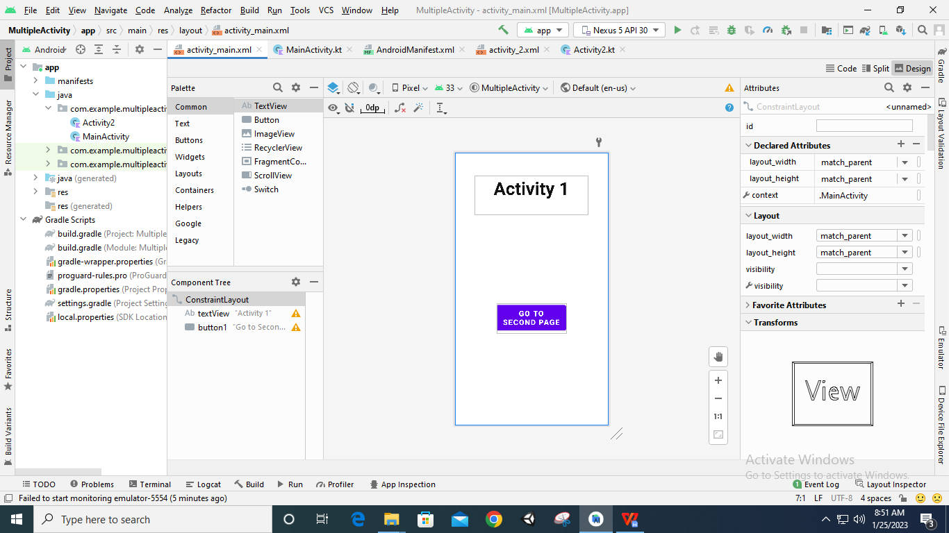

**Activity2.kt**

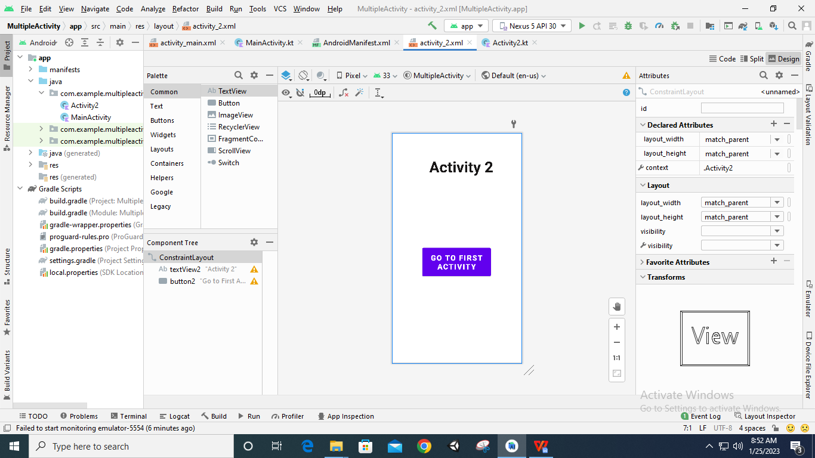

1. **Code**

**AndroidManifest.xml**

*<?***xml version="1.0" encoding="utf-8"***?>*<**manifest xmlns:android="http://schemas.android.com/apk/res/android"  
 package="com.example.multipleactivity"**>  
  
 <**application  
 android:allowBackup="true"  
 android:icon="@mipmap/ic_launcher"  
 android:label="@string/app_name"  
 android:roundIcon="@mipmap/ic_launcher_round"  
 android:supportsRtl="true"  
 android:theme="@style/Theme.MultipleActivity"**>  
 <**activity  
 android:name=".Activity2"  
 android:exported="true"**>  
 <**intent-filter**>  
 <**action android:name="com.example.multipleactivity.Activity2"** />  
 <**category android:name="android.intent.category.DEFAULT"** />  
 </**intent-filter**>  
 </**activity**>  
 <**activity  
 android:name=".MainActivity"  
 android:exported="true"**>  
 <**intent-filter**>  
 <**action android:name="android.intent.action.MAIN"** />  
 <**category android:name="android.intent.category.LAUNCHER"** />  
 </**intent-filter**>  
 </**activity**>  
 </**application**>  
  
</**manifest**>

**MainActivity.kt**

**package** com.example.multipleactivity  
  
**import** androidx.appcompat.app.AppCompatActivity  
**import** android.os.Bundle  
**import** android.widget.Button  
**import** android.content.Intent  
  
**class** MainActivity : AppCompatActivity() {  
 **override fun** onCreate(savedInstanceState: Bundle?) {  
 **super**.onCreate(savedInstanceState)  
 setContentView(R.layout.*activity_main*)  
  
 **var** btn: Button =findViewById(R.id.*button1*)  
  
 btn.setOnClickListener()**{  
 var** in1= Intent(**"com.example.multipleactivity.Activity2"**)  
 startActivity(in1)  
 **}** }  
}

**Activity2.kt**

**package** com.example.multipleactivity  
  
**import** androidx.appcompat.app.AppCompatActivity  
**import** android.os.Bundle  
**import** android.widget.Button  
  
**class** Activity2 : AppCompatActivity() {  
 **override fun** onCreate(savedInstanceState: Bundle?) {  
 **super**.onCreate(savedInstanceState)  
 setContentView(R.layout.*activity_2*)  
  
 **var** btn2: Button =findViewById(R.id.*button2*)  
 btn2.setOnClickListener()**{** finish()  
 **}** }  
}

1. **Output**

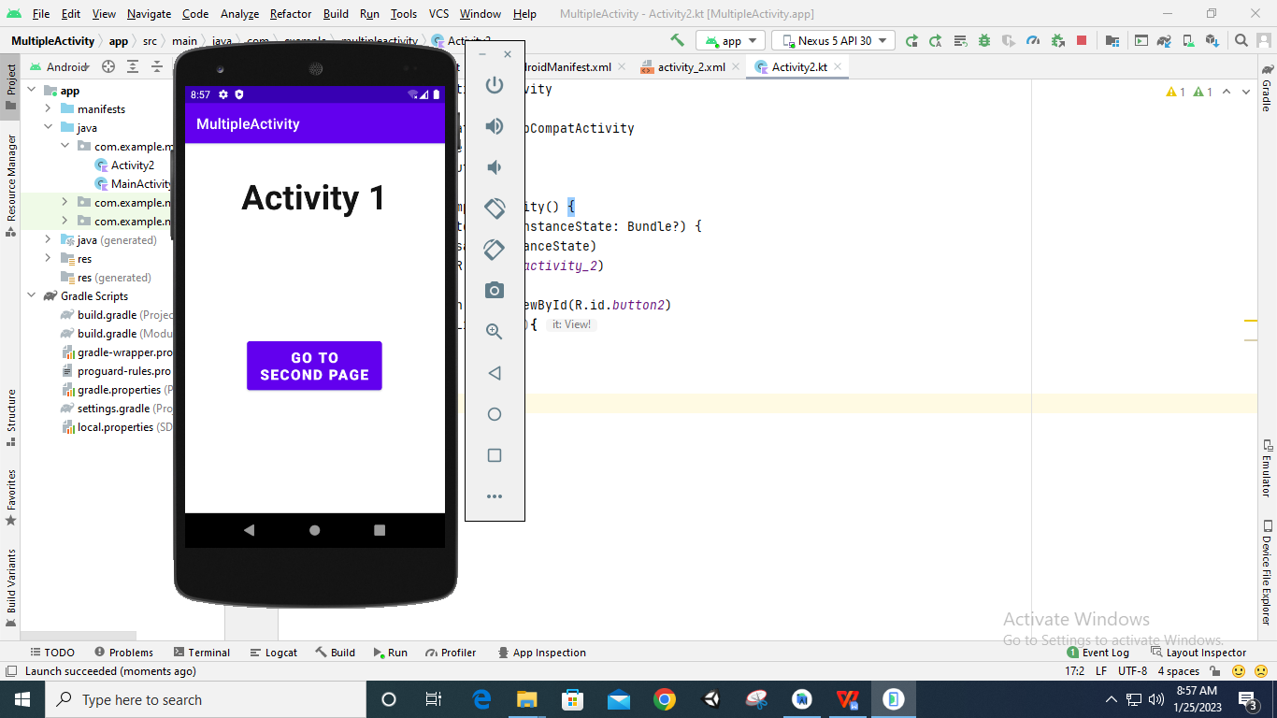

**After Clicking the button ‘GO TO SECOND PAGE’**

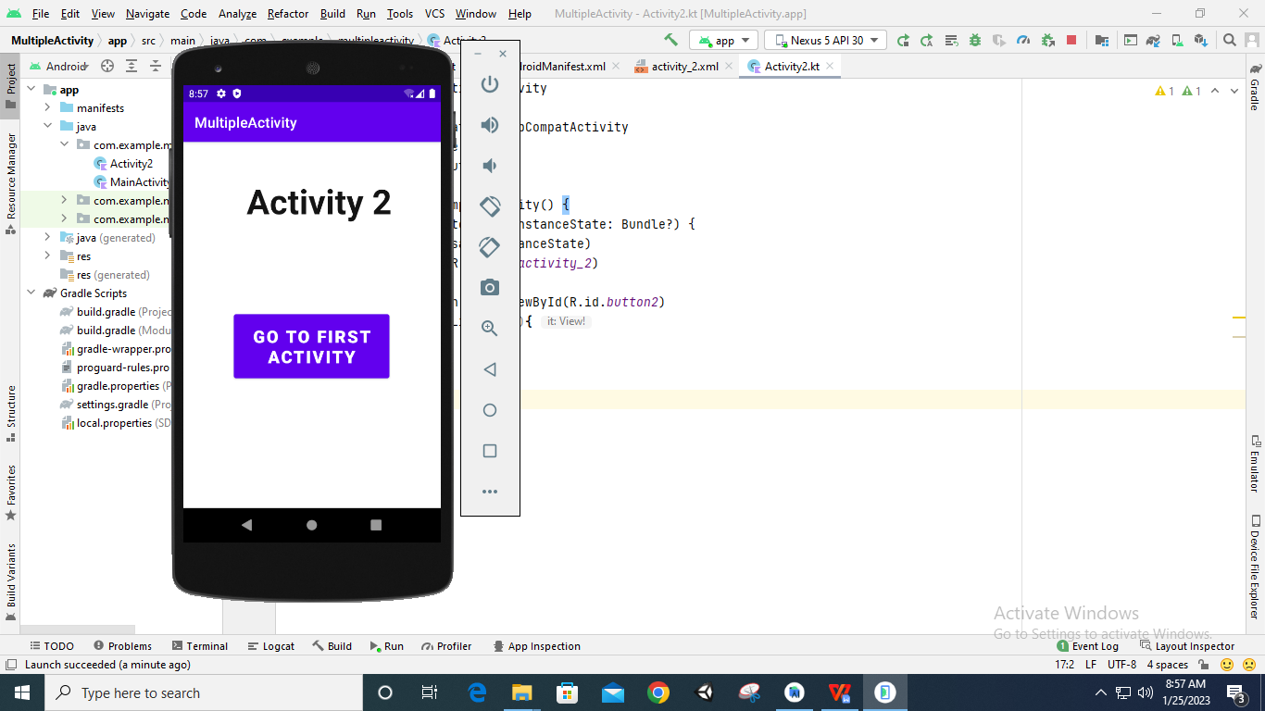

**After Clicking the button ‘GO TO FIRST ACTIVITY’**

